Instructor Notes: DI-1500 v9

There have been a few minor changes to the course for v9.0.

Please follow the instructions outlined below to ensure you can complete the required labs:

If you need to reset the course files:

1. Browse to:

C:\Pentaho-Training\reset scripts

1. Double click on:

DI-1500.cmd

1. Enter option: 1

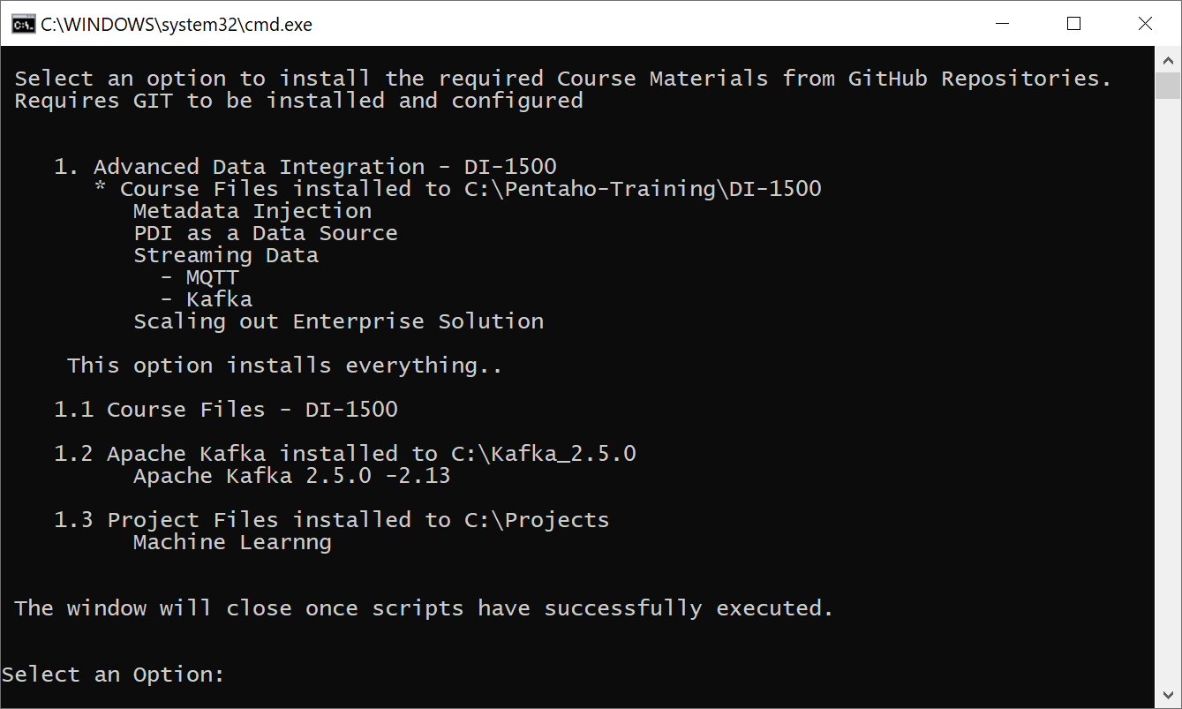

This will clone **all** the latest course files. The window will automatically close once completed.

Note: Confluent Kafka has been replaced with Apache Kafka v2.5

1. Check that the course files have been updated.

Module 2 – PDI as a Data Source

CDA

From October 14th APIXU relaunches as WeatherStack. The tr_weather_cda.ktr has been updated to reflect the changes in api.

Google BigQuery

The lab should only be demonstrated by the Instructor. A new account has been created which requires a new authentication key.

The following file will help execute example queries. If you switch to the new UI you will find the queries saved.

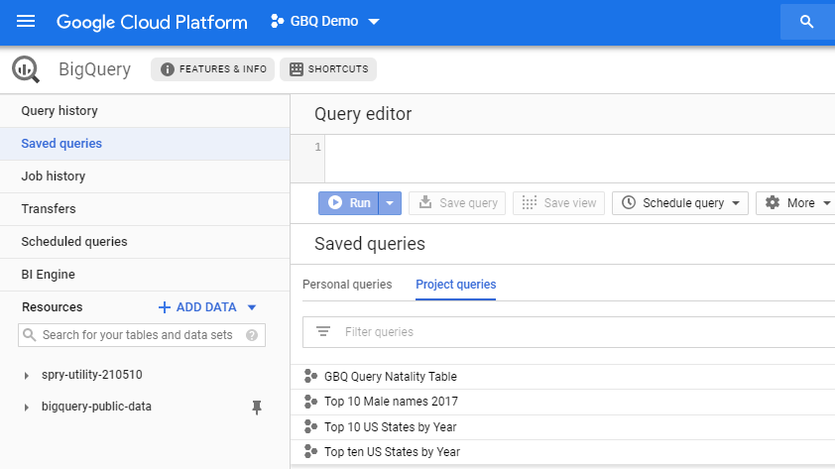

The Transformation has been updated to include the required account authentication email and path to key.

Module 3 – Streaming Data

MQTT – Mosquitto

The Mosquitto Broker service now starts automatically.

Added: Use Case – Logistics Sensor Data

Note: This transformation will only be added if the reset script is RUN. The output can be used as a Pentaho Data Service to populate a C-Tools dashboard.

**Logistics Sensor Data**

tr_mqtt_producer.ktr

the sensordata stream is streamed in JSON format

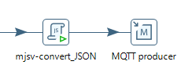

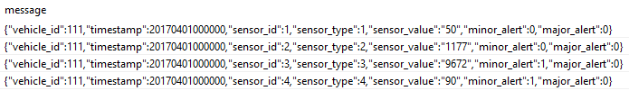

tr_mqtt_consumer.ktr

By default the consumer is processing:

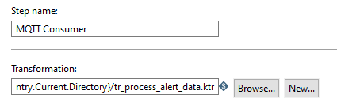

tr_process_alert_data.ktr

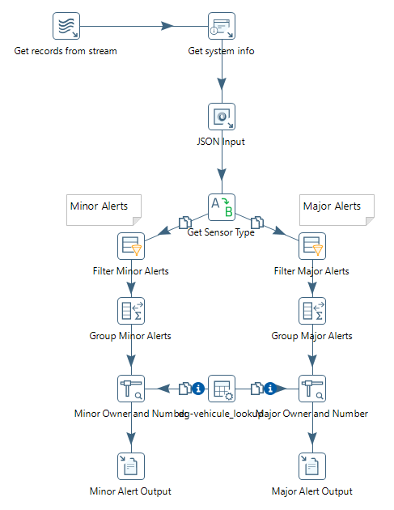

tr_process_sensor_data.ktr

Or point the consumer step to..

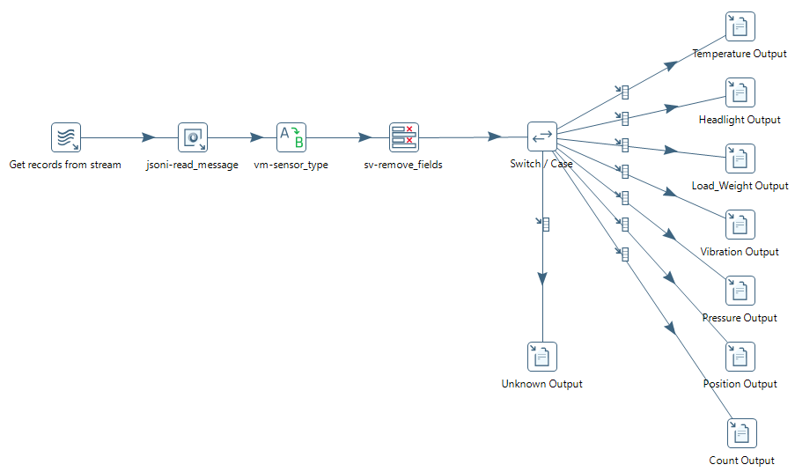

Module 4 – Scalability

Exercise: ‘Round Robin or Copy’ has been removed from the course files but kept in the pptx.

Exercise: ‘Transactional Transformations’ has been removed from the course files but kept in the pptx.